1) Non-functional requirements describes how system should work, such as performance, security, reliability and usability. They affect system architecture and technological choices
2) Ecosystem includes libraries, frameworks, tools and community supports. A strong ecosystem speeds up development and improves code quality. For example Python language. Thanks to strong ecosystem you can use python for data analysis, game dev, ml and etc
3)Open-source communities acts like a open net or more like a group chat. Where everyone shares knowledge and can work on projects together
4)PDD in jail. In simple words TDD means writing tests before code. It supports Agile by enabling fast feedback and by giving better code quality
5) The observer pattern allows objects to be notified when some object changes state. This pattern can be helpful when making system like notification services
6)Fault tolerance means the system works even when problems happen. Backups and retries help improve it.
7) Reliability means the system works correctly over time. It depends on testing and code quality.
8) When software engineers use strong security their depandability become week or when they use strong depandability then their security become week. To balance it they use risk-analysis.
9)Agile depends on iterrative development and adapts to change. Scrum uses roles like product owner or scrum master and works in short sprints
10)Secure software development prevents vulnerabilities from the start. Practices like input validation and least privilege reduce security risks
11) LMS- Library managment system, U-user, Ac-account, Lian- librarian, L – library, A - author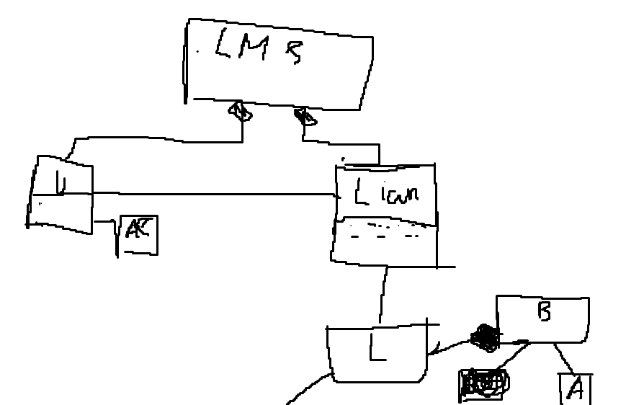
12)
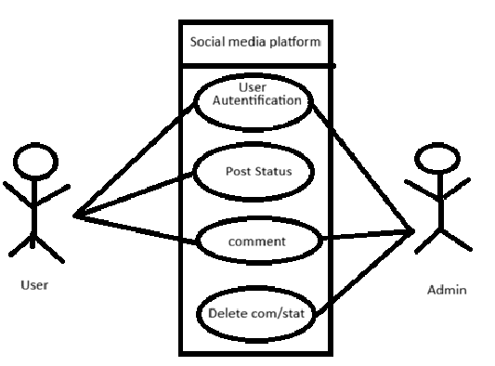

13)
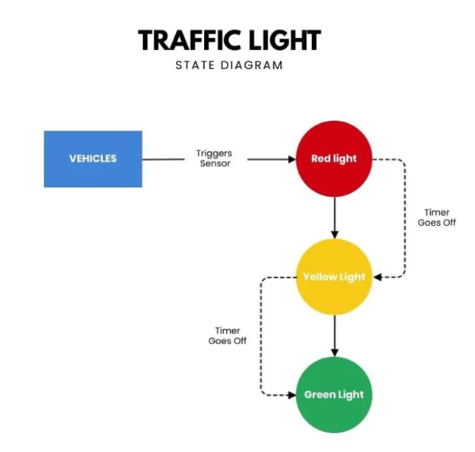
14)
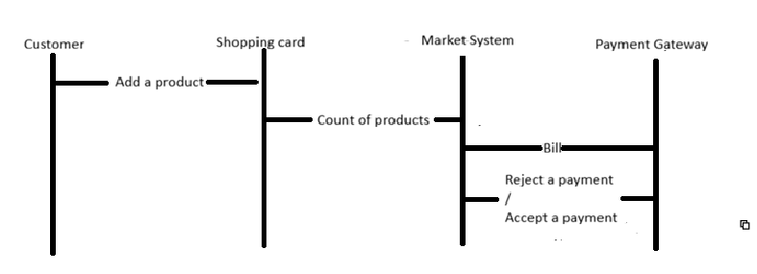

15) Client giving a request and server proces request and give responce. They comunicate by HTTP or REST. Server store data, user store UI and local tests
16) CBSE create a model with finished components and each component is independent. Benefits: speed up developing and easy testing.
17) Event driven architecture its when components comunicate with each other when some event happen. Example: online shops. Events in online shops: payment component, delivery component and e.t.c.
18) Adapter is usefull in integration old API with new interface. Example: new payment gateway in online shop.
19)The facade pattern provides a simplified interface for difficult subsystems. For example: general unified API.
20)Model-view-controller (MVC) architecture divide an application into 3 parts such as Model, View, Controller. Model - data and logic , View - presentation, Controller - connection and processing input.

